Action Plan for Implementing the Programme of Work on Protected Areas

of the Convention on Biological Diversity

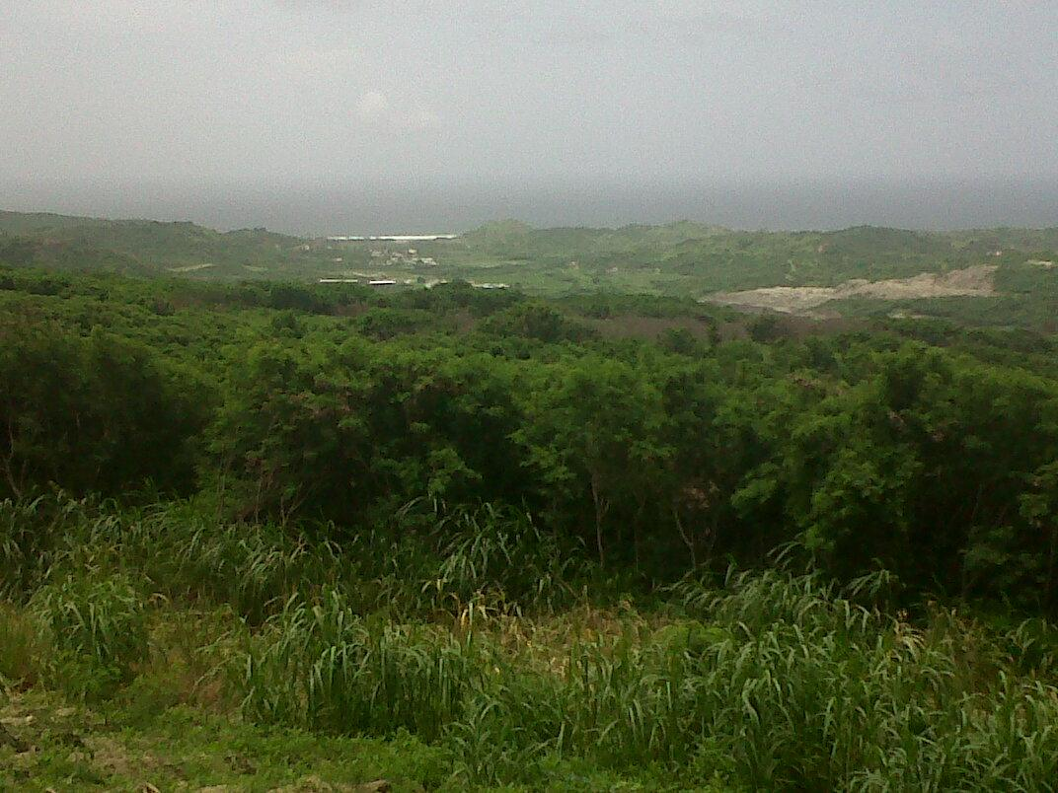

(BARBADOS)

Submitted to the Secretariat of the Convention on Biological Diversity June 22nd

Protected area information:

PoWPA Focal Point:
Gayle Francis-Vaughan
Permanent Secretary,
Ministry of Environment and Drainage,
1st Floor S.P Musson Building, Hincks Street,
Bridgetown Barbados

Lead implementing agency:
Natural Heritage Department
Mr. Steve Devonish
Director
Natural Heritage Department
Sturges, St. Thomas
Barbados

Folkestone Marine Reserve
St. James
Barbados

Multi-stakeholder committee:
The Working group on Biodiversity is made up of experts in various fields. Recognising the importance of sound scientific advice and the lack of all relevant spheres of expertise within the confines of the Ministry, the Working Group on Biodiversity was convened to advise the Ministry on general biodiversity issues and matters related to the implementation of the Convention on Biological Diversity. The committee is chaired by Dr. Julia Horrocks and includes representatives of the University of the West Indies, Ministry of Agriculture, Fisheries Division, Coastal Zone Management Unit, National Conservation Commission and the Veterinary Services and has as its terms of reference to advise on national policy and recommend strategies for the management and conservation of marine and terrestrial biodiversity; to advise and provide necessary technical input for projects in the area of biodiversity; to advise on the development of a database on biodiversity and to review and monitor the status of marine and terrestrial biodiversity in Barbados.

Graeme Hall Ecosystem Management Committee
To move towards effective coordination of Barbados First Ramsar Site, the Director, Natural Heritage Department convened the Graeme Hall Ecosystem Management Committee to address the issues related to the effective management. To date issues related to the management of Graeme Hall Swamp Ecosystem are addressed by a plethora of government ministries and departments, consolidated management under one authority will lead to more effective use of issues and more effective management of the swamp. The Drainage Unit is responsible for issues related flood mitigation, the Ministry of health for vector control, the Ministry of Agriculture engages in activities in sections of the ecosystem and the Environmental Protection Department for issue related to water quality.
The Committee is made up of representatives of the Ministry of Environment, Water Resources and Drainage, the Coastal Zone Management Unit, Environmental Protection Department, Drainage Department and the Water Authority.

It is proposed that a National Park Advisory Committee be set up specifically to facilitate the implementation of the National Park Plan in Barbados.

Description of protected area system
Coverage

The Ministry undertook the Environmental Management and Land Use Planning for Sustainable Development Project, a component of which was The National Park. The National Park Development Plan proposes a range of projects to guide the development of the Barbados National Park and Natural Heritage Conservation Areas for Barbados. The plan utilizes an ecosystem approach to the National Park Planning Process for Barbados and recognizes the dynamics and resilience of ecosystems and their limits.
The proposed National Park encompasses the entire Scotland District which is one seventh of the island. The total land area of the proposed Barbados National Park is 7300 hectares, 17 % of the island's total land area. The proposed boundary includes both terrestrial and the marine environment to 200 metre depth or 2.0km which ever is encountered first.
One Natural Heritage Conservation Area is the Graeme Hall Swamp, the area is approximately 33.23 hectares.

Description and background
The PDP details the Barbados system of Parks and Open Spaces which comprises six categories:
- OS 1 The Barbados National Park
- OS 2 Natural Heritage Conservation Areas
- OS 3 Coastal Landscape Zone
- OS 4 Public Parks and Open Spaces
- OS 5 National Attractions
- OS 6 Barbados National Forest Candidate Sites

The Proposed Barbados National Park
Five landscape Units are used to describe the Proposed National Park. It encompasses the St. Lucy Coastal Cliffs and extends from Gays Cove to Archers Bay as an exposed coastal landscape of high cliffs. It includes some bays and and coves.

The other distinguishable landscape is the Savannahs, this coastal area is characterised by a wide range of physical and geomorphological features including wide sandy beaches, scrub and rough grassland and woodlands.
Chalky Mount is the third an undulating landscape of hills and valleys. The Scotland basin which is very susceptible to erosion and Hackleton's Cliff, a coastal landscape comprising a narrow beach and rocky shorline backed by forest and rock outcrops.
Graeme Hall Swamp
The swamp is also Barbados' only Ramsar site. Graeme Hall is on the south coast of Barbados in Worthing, Christ Church. The swamp is located 5km outside of the city limit of the capital Bridgetown. Highway seven (7) is a major road artery which runs parallel to the swamp and is well serviced by public transportation Elevation: The swamp is located at sea level.
Graeme Hall Swamp is an important ecosystem to Barbados and has several unique features. The swamp is connected to the St. Lawrence lagoon and is the last remaining complete ecosystem of its type left in Barbados. It has the largest body of inland water (4.86 ha / 12 acre lake in addition to wetland area) on the island and contains the largest remaining area of red mangrove (Rhizophora mangle) and white mangrove (Laguncularia racemosa) forest. The swamp ecosystem has been proposed as a Barbados National Heritage Site, and has also been established as one of two Caribbean Coastal Marine Productivity Programme (CARICOMP) monitoring sites in Barbados (Oxenford and Parker 1998).
Folkstone Marine Reserve
Folkestone Marine Reserve was established in 1981 and was Barbados’ first marine protected area. The reserve consists of four zones with different permissible uses -Scientific zone designated for marine research; Northern Water Sports Zone; Recreational Zone and the Southern Water Sports Zone.

Governance types
The Proposed National Park
The Government of Barbados formally constituted the Natural Heritage Department in 2005 and the department now has responsibility for all issues related to biodiversity and biodiversity conservation, in addition to its National Park mandate. The Department is mandated to define the guiding principles, vision, long-term aims and policies for the management of protected areas in Barbados. The mission of the Department is to promote the conservation of special unique biomes of Barbados through effective management of a network of terrestrial and marine protected areas for the recreation and enjoyment of Barbadians, and by the creation of innovative ideas and initiatives, facilitate the sustainable development of those living in these areas.

Graeme Hall
This site is jointly owned by the Graeme Hall Nature Sanctuary and the Government of Barbados which has vested the land in the Barbados Agricultural Development and Marketing Corporation (BADMC). The Ministry of Energy and the Environment serves as the Administrative Authority for the site.
The Graeme Hall Nature Sanctuary and the BADMC have management responsibility for their portions of the site.

Policy Framework/ Enabling Legislation
The Draft National Physical Development Plan (PDP) for Barbados is intended to provide a vision for future growth and development of Barbados and sets out policies to guide relationships among land uses, community facilities and physical infrastructure.
The PDP details the Barbados system Parks and Open Spaces, the goal of which is to promote landscape preservation, ensure the conservation of natural areas, meet the active and passive recreation needs of residents of Barbados and enhance amenities for residents and tourist alike. The system also seeks to establish a National Park which will protect and conserve the natural and cultural assets of the area while supporting the social and economic development of existing communities within the park boundaries
The PDP details the Barbados system of Parks and Open Spaces, which has six categories and also details specific land use policies for each of the categories.
The National Park Plan also makes recommendations on the need for a new National Parks Act as well as the administrative and organizational structure necessary.
The Coastal Zone Management Act, 1998-39, allows for the provision of more effective management of the coastal resources of Barbados, for the conservation and enhancement of those resources and for related matters such as giving the Coastal Zone Management Unit the power to recommend for the approval of the Minister designated marine areas as restricted areas for the following purposes:
- the preservation or enhancement of the natural beauty of the areas;
- the protection or rehabilitation of the flora and fauna found in the areas;
- the protection of wrecks and other items of archaeological and historical interest found in the areas;
- the promotion of the enjoyment by the public of the areas;
- the promotion of the scientific study and research in respect of the areas.

Key threats
Within the Ramsar site:
The swamp ecosystem consists of brackish water and has become isolated from tidal exchange with the sea, mainly due to commercial beach-front development, the construction of a coastal highway, elevation of the south coast shoreline by approximately 50 cm and also as a result of significant sand accretion on the beach. Several historical connections to the sea have been reduced to a single channel that is now controlled by a sluice gate; the effective operation of the sluice gate is however hampered by sand accretion. This has led to a long-term accumulation of nutrients in the swamp water system, as well as poor surface and sub-surface water circulation, low oxygen levels and high bacterial counts.

To date, fishing has been suspended pending a review of the health implications of the water quality concerning the suitability of fish for human consumption. In addition, the fish populations are being assessed for sustainability given the introduction of an aggressive tilapia species into the swamp.

The ecological character of the swamp may also be affected by run off from neighbouring agricultural fields and from the residential and commercial properties that surround this ecosystem.

Folkstone
The concentration of diverse values and activities and resulting competing demands and conflicts, the high and increasing demand for underwater recreational activities and the deterioration of the resources are the main threats to Folkestone.

Barriers for effective implementation
Limited Agency capacity (equipment etc)
Lack of enabling legislation
Limited financial resources
Private ownership of areas identified for conservation
Developmental conflicts

National Targets and Vision for Protected Areas
"This Government believes that there is a need to preserve the environment as breathing space for ordinary people at whatever cost." The Government therefore is committed to establishment of a comprehensive system of Parks and Open Spaces for Barbados with the designation of the Barbados National Park and Natural Heritage Conservation Areas.

Progress in and plans for achieving the goals of the Programme of Work on Protected Areas
Progress: 0 = no work, 1 = just started, 2 = partially complete, 3 = nearly complete, 4 = complete
Goals of the Programme of Work on Protected Areas | Progress 0-4
- Progress in establishing and strengthening national and regional systems of protected areas (1.1) | 2
- Progress in integrating protected areas into broader land- and seascapes and sectors so as to maintain ecological structure and function (1.2) | 2
- Progress in establishing and strengthening regional networks, transboundary protected areas (TBPAs) and collaboration between neighbouring protected areas across national boundaries (1.3) | 1
- Progress in substantially improving site-based protected area planning and management (1.4) | 2
- Progress in preventing and mitigating the negative impacts of key threats to protected areas (1.5) | 1
- Progress in promoting equity and benefit-sharing (2.1)  - Progress in assessing and implementing diverse protected area governance types (2.1) | 1
- Progress in enhancing and securing involvement of indigenous and local communities and relevant stakeholders (2.2) | 2
- Progress in providing an enabling policy, institutional and socio-economic environment for protected areas (3.1)  - Progress in assessing the contribution of protected areas to local and national economies (3.1) | 3
- Progress in building capacity for the planning, establishment and management of protected areas (3.2) | 2
- Progress in developing, applying and transferring appropriate technologies for protected areas (3.3) | 1
- Progress in ensuring financial sustainability of protected areas and national and regional systems of protected areas (3.4) | 1
- Progress in strengthening communication, education and public awareness (3.5) | 1
- Progress in developing and adopting minimum standards and best practices for national and regional protected area systems (4.1) | 3
- Progress in evaluating and improving the effectiveness of protected areas management (4.2) | 1
- Progress in assessing and monitoring protected area status and trends (4.3) | 1
- Progress in ensuring that scientific knowledge contributes to the establishment and effectiveness of protected areas and protected area systems (4.4) | 2
- Progress in marine protected areas | 2
- Progress in incorporating climate change aspects into protected areas | 2

Priority activities for fully implementing the Programme of Work on Protected Areas:
Activities | Timeline
- Public Education and Stakeholder Engagement | Immediate –short term
- Implementing Enabling Legislation | Short- term
- Institutional Development and Sustainable Financing- Capacity Building of Park Management agencies | Immediate- long term
- Monitoring and Evaluation | Immediate – long term

Action Plans (detailed steps) for completing priority activities for fully implementing the Programme of Work on Protected Areas:

  - Activity 1: Public Awareness and Stakeholder Engagement
Key steps | Timeline | Responsible agencies | Indicative budget
Identify stakeholders in park and conservation areas | immediate | Ministry  NHD  Folkestone | -
Development of a Public Awareness and Stakeholder engagement strategy | Immediate | consultant | USD 50,000
Implementation of Strategy- consultation and public awareness activities, awareness survey | short | Ministry, NHD, Folkestone, consultant | USD 100,000

  - Activity 2: Implementation of Enabling Legislation
Key steps | Timeline | Responsible agencies | Indicative budget
Laying of Legislation in Parliament |  | Solicitor General's Chambers

  - Activity 3: Institutional Development and Sustainable Financing- Capacity Building of Park Management Agencies
Key steps | Timeline | Responsible agencies | Indicative budget
Assess the capacity needs and gaps of existing park management agencies and the proposed MMA | Medium term | consultant | USD100,000
Development of recommendations for appropriate management structure and strengthening of identified agencies | Medium term | Consultant  Ministry  NHD  Folkestone | USD100,000
Assessment of Financial viability of existing parks | Medium term | Consultant | USD100,000
Identify mechanisms for sustainable financing | Medium term | Consultant | USD100,000

