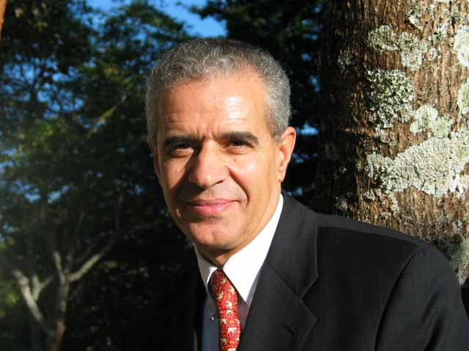
contribution from dr. ahmed djoghlaf, executive secretary of the convention on biological diversity, to the seminar on desertification and its implications
2 – 4 april 2007

Desertification and Biodiversity

Dry and sub-humid ecosystems cover 47% of the Earth’s land surface. They are not barren land or dead landscapes; rather they contain a number of important well-adapted species. Indeed some of the world’s most important food crops originated in dry and sub-humid lands including wheat and olives. 44% of the world’s cultivated systems are located in these unique ecosystems. They provide, therefore, many essential goods and services. In grasslands and savannahs alone, more than 10,000 different grass species sequester carbon, filter water, provide fodder for livestock and supply materials for housing, clothing and handicrafts.

With 90 per cent of the 2 billion inhabitants of dry and sub-humid lands living in developing countries, addressing threats to these ecosystems and to the associated goods and services they provide, is essential for development. However, at least 70% of the world’s dry and sub-humid lands are affected by desertification which contributes to the unprecedented loss of biodiversity of our planet. The current rate of loss of biodiversity is estimated to be 1,000 times higher than the natural rate of extinction. All ecosystems are affected including dry and sub-humid lands. Indeed, no less than 2,311 species are threatened or endangered in dry and sub-humid lands.

The cost of desertification and drought is estimated at approximately $ 42 billion per year. These costs are borne by people and biodiversity alike and the links between healthy dry and sub-humid lands and healthy and prosperous populations in dry and sub-humid lands are clear.

In North Africa, at least 40 million people living in dry and sub-humid lands rely on biodiversity resources to maintain their livelihoods. The biological diversity of dry and sub-humid lands also provides an important source of medication with one-third of all plant-based medicines currently used in the United States derived from dry and sub-humid lands species.

The threats to dry and sub-humid lands from desertification, invasive alien species, climate change, and other factors, therefore impact both people and biodiversity. With one out of every three dry and sub-humid land species that has been assessed classified as threatened, and one of six classified as endangered or critically endangered, there is a need for immediate and urgent action. In fact, it is predicted that if current rates of biodiversity loss continue, the current global species abundance in deserts and desert margins may decrease by 15% between now and 2050.

At the same time, biodiversity resources are a critical component of many efforts to combat desertification. Plant species which are well-adapted to harsh conditions can stabilize soils, protect waterways and regenerate degraded land. Crops and livestock which are pest and drought resistant are important contributors to sustainable livelihoods in dry and sub-humid lands while wild species form an integral component of alternative livelihood options to reduce the impact of those human activities which contribute to desertification. Under changing climatic conditions, the role of biodiversity in combating desertification is becoming even more crucial.

In response to the urgent need to address desertification and other threats to dry and sub-humid lands biodiversity the Convention on Biological Diversity and the United Nations Convention to Combat Desertification have adopted a joint work programme, which seeks to address the multiple and increasing threats to dry and sub-humid lands, biodiversity, human populations, and life in general.

At the eighth meeting of the Conference of the Parties to the Convention on Biological Diversity, held in Curitiba, Brazil on 20-31 March 2006, Parties called for closer collaboration between these two important conventions in recognition of the opportunities for mutually-supportive benefits that can be achieved when combating desertification and the conservation and sustainable use of biodiversity go hand-in-hand.

Addressing this major environmental and development challenges calls for the active involvement of all stakeholders including parliamentarians. I am very pleased, therefore, that the Pan-African Parliament is continuing to build on the momentum that was created last year during the International Year of Deserts and Desertification by convening a seminar on desertification and its implications. It is fitting that such a meeting is taking place first in Africa, one of the continents that is most affected by desertification and, more specifically, in Algiers, the capital of the country which has played a leading role in promoting the very idea of the celebration of the International Year of Deserts and Desertification.

During your deliberations I invite you to consider both the negative implications that desertification has on biodiversity and the positive role that biodiversity can play in combating desertification and preserving life and livelihoods in the world’s dry and sub-humid lands. I wish you a very successful deliberation and look forward to receiving the report of your meeting to share your experience with other regions of the world.

