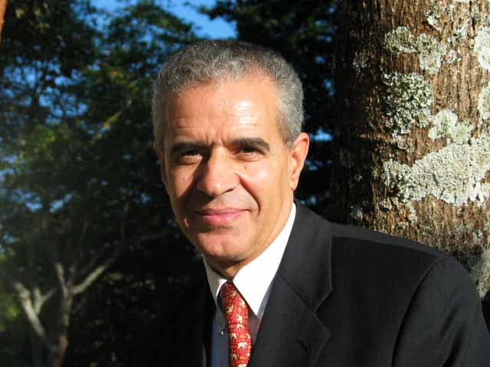
It is with great pleasure that I extend my congratulations to you and your staff, on the occasion of the tenth anniversary of the entry into force of the United Nations Convention to Combat Desertification (UNCCD), for the many achievements of the past 10 years. The successful world wide celebration of 2006 as the International Year on Deserts and Desertification attests to the global recognition of the importance of the UNCCD and its contribution to the betterment of life on Earth.

I would also like to take this opportunity to congratulate the entire UNCCD Secretariat for the landmark GEF Council decision on the approval of the amendment of the GEF Instrument for the GEF to act as a financial mechanism of the UNCCD in countries experiencing serious drought and/or desertification, particularly in Africa.

As the Rio Convention with the most Parties (191), the UNCCD brings together people and the environment in the fight against land degradation in dry and sub-humid lands.

Often referred to as the “Convention for Africa”, the UNCCD is seen by many as a Convention that responds to the needs of the poorest and most marginalized populations of this continent. In fact, with 90% of the inhabitants of drylands living in developing countries, the work of the UNCCD is critical to the achievement of the Millennium Development Goals worldwide.

In recognition of the value of biodiversity resources in dry and sub-humid lands, the UNCCD accords special attention and consideration to biodiversity-based livelihoods in its areas of work. And yet, with one out of three assessed dryland species classified as threatened and one of six classified as endangered or critically endangered, it is clear that we need to do more.

In this regard, the Convention on Biological Diversity (CBD) is proud to partner with the UNCCD through our joint work programme, which seeks to address the multiple and increasing threats to dry and sub-humid lands, biodiversity, human populations, and life in general. Already, as you know, we have held joint workshops on synergies, including the most recent one in Antigua and Barbuda from 20 to 23 November 2006.

While there is much more than we can do for people and the environment in dry and sub-humid lands, the stage is well set. The CBD is poised to support enhanced implementation of our two Conventions. At the eighth meeting of our Conference of the Parties, held in Curitiba Brazil on 20-31 March 2006 Parties called for closer collaboration between the CBD and the UNCCD.

On the occasion of the tenth anniversary of the UNCCD, I would like to reaffirm my full commitment to spare no effort to enhance the complementarity of our two mutually supportive conventions and the synergy among our two convergent processes.

