MESSAGE OF AHMED DJOGHLAF,
EXECUTIVE SECRETARY OF THE CONVENTION ON BIOLOGICAL DIVERSITY,
ON THE OCCASION OF
THE INTERNATIONAL DAY FOR BIOLOGICAL DIVERSITY, 22 MAY 2006
“PROTECT BIODIVERSITY IN DRYLANDS”

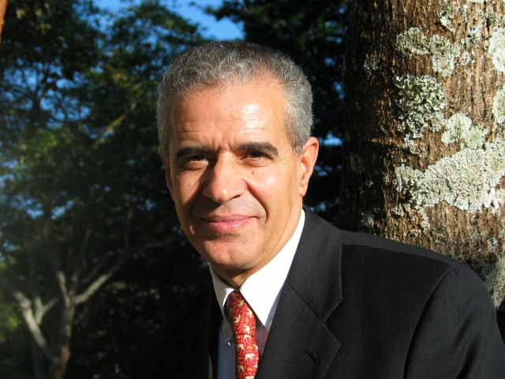
The logo for this year’s International Day for Biological Diversity includes a cactus flower, symbolizing, as the writer and photographer Randall Henderson said, “courage that triumph[s] over appalling obstacles”. Too often, discussions of drylands evoke images of barren sands and parched earth, devoid of life. Instead, we need to note Henderson’s words: “For those seeking beauty the desert offers nature’s rarest artistry.”
Drylands are teeming with a spectacular parade of unique and well adapted biodiversity. From vast grassland habitats where birds abound, to lush Mediterranean landscapes dominated by endemic succulents, drylands are the cradle of much of the richness of our planet. The Cape Floral Kingdom in South Africa for example, covers less that 0.5 per cent of the area of Africa, but accounts for almost 20 per cent of the continent’s flora.
The beauty of drylands diversity is also manifested in its importance to the communities who live in these regions. In drylands-dominated Senegal, wild resources and non-timber forest products provide 50 per cent of rural household incomes. In general, the biodiversity of drylands provides critical ecosystem services on which humanity relies for food, shelter, and livelihoods. In fact, drylands biodiversity helps maintain 44 per cent of the world’s cultivated land. The biodiversity in these regions also supplies essential products for our health. One third of the plant-based drugs in the United States are derived from drylands biodiversity.
The Parties to the Convention on Biological Diversity recognized the value of drylands when they adopted the programme of work on the biological diversity of dry and sub-humid lands at their fifth meeting. Since then, we have made some progress in protecting this unique biodiversity. In sub-Saharan Africa, for example, there has been a steady increase in the populations of grassland and savannah herbivores within protected areas.

Unfortunately, outside the boundaries of protected areas, these positive trends have yet to be achieved, and more than 2,300 known drylands species remain threatened or endangered. While drylands species have developed a number of unique adaptations to dry conditions, the impact of climate change is emerging as an unprecedented challenge to all life in drylands. For the more than one billion people affected by drought and desertification, adaptation to climate change will be a matter of survival. The speedy implementation of the mutually supportive programmes of work of the Rio conventions—the Convention on Biological Diversity, the Convention to Combat Desertification, and the United Nations Framework Convention on Climate Change, is the solution to addressing the root causes of desertification and alleviating the escalating risks of famine and disease resulting from the failure of dryland ecosystems.
The implementation of the three objectives of the Convention on Biological Diversity is of critical importance to the achievement of the Millennium Development Goal of halving the rate of poverty in the world by 2015. In 2005, at the United Nations Millennium Summit, drylands were identified as an essential factor for the achievement of sustainable development. Eight of the world’s ten poorest countries contain a majority of drylands and, as such, actions to conserve and maintain the health of drylands are intimately linked to the achievement of the Millennium Development Goals (MDGs).
It is for this reason that we have a responsibility, through the adoption of the 2010 biodiversity target and the Millennium Development Goals to improve the quality of human life and biodiversity in drylands.
It is for the same reason that 2006 was named the International Year of Deserts and Desertification. It is also the reason that this year’s theme for the celebration of the International Day for Biological Diversity is “Protect Biodiversity in Drylands”. And it is for the same reason that 122 Ministers and other Heads of Delegation attending the eighth meeting of the Conference of the Parties in Curitiba, Brazil, demonstrated their solidarity and support to the affected countries and their people by marking the celebration of the International Year of Deserts and Desertification.
The International Day for Biological Diversity provides us with a unique opportunity to renew our commitment as a community of nations bound by a common, long-term, ecological destiny.
“To those who come to the desert with tolerance it gives friendliness; to those who come with courage it gives new strength of character.” I invite you all to courageously support concrete actions to conserve and sustainably use the biological diversity of dry and sub-humid lands. Only by acting with courage, conviction and a sense of collective solidarity will we achieve the 2010 target in dry and sub-humid lands and save life on Earth.

