CALLING CHILDREN AND YOUTH TO ACTION

MESSAGE FROM DR. AHMED DJOGHLAF,
EXECUTIVE SECRETARY OF THE CONVENTION ON BIOLOGICAL DIVERSITY,
TO CHILDREN AND YOUTH OF THE WORLD

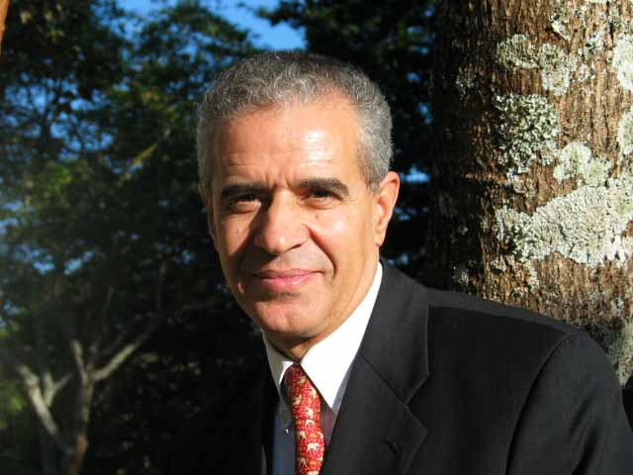

You, the children and youth of the world, make up almost one half of the world population of over six billion people. Your health and well-being are directly and seriously affected by environmental problems and biodiversity loss. This is unacceptable. You are a force that must make itself counted in the fight against the loss of biodiversity. Environmental protection has become a key component in the agendas of youth organizations all over the world. While every part of society has a responsibility for maintaining the environmental integrity of the community, young people have a particular interest in preserving a healthy environment, since they are the ones that will inherit it.

Eighty-five per cent of young people live in developing countries, where threats to the environment are inextricably linked to their health and safety. We know that environmental quality is one the key factors in determining whether a child survives the first years of their life. We also know that healthy school environments can significantly raise a child’s learning potential. In these countries, lack of available water often forces people—more often than not, children and women—to spend a lot of time fetching and carrying that precious commodity, often at great distances from their homes. We know that you are also the most susceptible to air pollutants in places where the natural environment does not filter them appropriately. It is also true that biodiversity loss increases the drudgery experienced by children and youth living in harsh environmental conditions, and therefore undermines your health.

You represent the future generation and the leaders of tomorrow. You are therefore in a key position, as future decision makers, to shape the direction of today’s decisions that may negatively impact on your adult life. You are in a key position but also in a position of great responsibility, as this planet awaits your action.

The unique contribution that the younger generation can and should make to the protection of the environment was recognized by the Earth Summit held in Rio de Janeiro, in June 1992. In adopting chapter 25 of Agenda 21, the 101 Heads of State or Government attending this meeting reaffirmed the need for “advancing the role of youth and actively involving them in the protection of the environment and the promotion of economic and social development”. I am making this call to you in the spirit of the 2002 Youth Declaration, adopted at the sixth meeting of the Conference of the Parties to the Convention on Biological Diversity, in The Hague, in which you expressed your desire to make your voices and grave concerns heard in the international biodiversity agenda. Your dynamism is our hope.

The Convention on Biological Diversity is about life on Earth. It is about our own survival as much as that of all living organisms that surround us. You, the children and youth of the world, are the epitome of life, and life is at the core of our mission. The Convention is an international agreement, a contract between nations to cooperate, an agreement geared towards action.

By protecting the planet’s biodiversity you will protect your own future and preserve life on Earth. You cannot afford to adopt a neutral status on such a vital issue. You have tremendous potential as catalysts for change. You are major stakeholders in ensuring the successful implementation of the Convention on Biological Diversity. We will all greatly benefit from working with you.

Last year, the United Nations decided that the period 2005-2014 would be the Decade on Education for Sustainable Development. This is a unique opportunity for you to link education to environmental protection. Education represents a unique chance to channel your concerns in the form of learning opportunities that lead to action in your own classrooms, your communities, and at the national and international levels.

Because the Convention on Biological Diversity is your Convention and your passport to tomorrow’s healthy environment, I call on you to be fully engaged in its implementation at a time when the Parties, countries of which you are citizens, have actively embarked on a new and exciting phase of its existence; a phase aimed at translating its objectives into practical achievements to tackle the day-to-day challenges of our global village.

The battle to protect life on Earth is yours, and the Secretariat of the Convention on Biological Diversity, that I have the honour to head in the years to come, will always be on your side as your partner and your faithful ally. To this end, a dedicated staff member within the Secretariat of the Convention, Mr. Mathieu Régnier, has been designated as your focal point.

The cause of biodiversity provides a unique opportunity to unite and cooperate. Let’s join forces to win this battle to stem its loss, a battle that no one can afford to lose and from which every human being on our planet stands to gain.

Montreal, 18 February 2006

