|  |  |  |
| --- | --- | --- |
| Macintosh HD:Users:bilodeau:Desktop:logos:template 2017:un.emf | Macintosh HD:Users:bilodeau:Desktop:logos:template 2017:unep-old.emf | **CBD** |

|  |  |  |
| --- | --- | --- |
|  |  | Distr.  GENERAL  CBD/SBSTTA/REC/23/6  29 November 2019  ORIGINAL: ENGLISH |

SUBSIDIARY BODY ON SCIENTIFIC, TECHNICAL AND TECHNOLOGICAL ADVICE

Twenty-third meeting

Montreal, Canada, 25-29 November 2019

Agenda item 7

# RECOMMENDATION ADOPTED BY THE SUBSIDIARY BODY ON SCIENTIFIC, TECHNICAL AND TECHNOLOGICAL ADVICE

23/6. Draft proposals to strengthen technical and scientific cooperation in support of the post-2020 global biodiversity framework

*The Subsidiary Body on Scientific, Technical, and Technological Advice,*

*Underlining* the importance of robust technical and scientific cooperation and other means of implementation in supporting the implementation of the post-2020 global biodiversity framework,

*Noting* the constraints and challenges encountered in the delivery of technical and scientific cooperation programmes under the Convention,

*Recognizing* that technical and scientific cooperation will need to extend across a wide range of fields and disciplines to support the mainstreaming of biodiversity in other sectors, and to address drivers of biodiversity loss,

*Recalling* decision 14/20, in particular paragraph 3,and *noting* the ongoing discussions on digital sequence information on genetic resources,

*Recalling* the importance of the clearing-house mechanism of the Convention on Biological Diversity as a key element for fostering technical and scientific cooperation as stated in Article 18(3) of the Convention and in decision X/15,

1. *Takes note* of the proposals to strengthen technical and scientific cooperation in support of the post-2020 global biodiversity framework contained in annex I below;
2. *Requests* the Executive Secretary, pursuant to decision 14/24 and subject to the availability of resources, to develop proposals for an inclusive process to review and renew technical and scientific cooperation programmes, including the Bio-Bridge Initiative, the Forest Ecosystem Restoration Initiative and the Global Taxonomy Initiative, in order to support the post-2020 global biodiversity framework, and to submit these proposals for consideration by the Subsidiary Body on Implementation at its third meeting;
3. *Invites* Parties, other Governments and relevant organizations, including members of the Consortium of Scientific Partners on Biodiversity, to submit to the Executive Secretary, by 20 January 2020:
   1. Additional views and suggestions regarding the proposals referred to in paragraph 1 above, including elements of technical and scientific cooperation for enabling technology horizon scanning, assessment and monitoring, avoiding duplication of related technologies considered by the Ad Hoc Technical Expert Group on Synthetic Biology;
   2. Examples of effective institutional mechanisms, partnerships, networks, and regional and subregional institutional arrangements;
4. *Requests* the Executive Secretary to further develop the proposals referred to in paragraph 1 above, taking into account the advice and amendments provided in annex I below and the submissions made by Parties, other Governments and relevant organizations, and to submit the updated proposals for consideration by the Subsidiary Body on Implementation at its third meeting and the Open-Ended Working Group on the Post-2020 Global Biodiversity Framework at its third meeting;
5. *Also requests* the Executive Secretary, in undertaking the task in paragraph 4 above, to, as far as possible and subject to the availability of resources, provide:
   1. Information on the advantages and disadvantages of the three options for institutional arrangements;
   2. Information on the costs associated with the three options;

(c) An initial compilation and analysis of information on relevant institutional arrangements, and networks at the global, regional and/or subregional levels relating to different thematic topics, including ongoing work by the Intergovernmental Science-Policy Platform on Biodiversity and Ecosystem Services and its task forces;

1. *Welcomes* the draft terms of reference of the Informal Advisory Group on Technical and Scientific Cooperation as contained in annex II below, and *invites* the Subsidiary Body on Implementation at its third meeting to consider them and make a recommendation to the Conference of the Parties at its fifteenth meeting.

*Annex I*

**DRAFT PROPOSALS TO STRENGTHEN TECHNICAL AND SCIENTIFIC COOPERATION IN SUPPORT OF THE POST-2020 GLOBAL BIODIVERSITY FRAMEWORK**

1. **Introduction**
2. Article 18(1) of the Convention requires Parties to promote international technical and scientific cooperation in the field of conservation and sustainable use of biological diversity, where necessary, through the appropriate international and national channels. Other parts of Article 18 also require Parties, in accordance with national legislation and policies, to encourage and develop methods of cooperation for the development and use of technologies, including indigenous and traditional technologies, in pursuit of the objectives of the Convention, and, subject to mutual agreement, promote the establishment of joint research programmes and joint ventures for the development of relevant technologies relevant to the objectives of the Convention. In addition, related articles are also relevant to technical and scientific cooperation, such as Articles 12 (Research and Training), 16 (Access to and Transfer of Technology), 17 (Exchange of Information) and 19 (Handling of Biotechnology and Distribution of its Benefits).
3. The Conference of the Parties has adopted a number of decisions relating to technical and scientific cooperation and technology transfer. These include decisions VII/29, VIII/12, IX/14, X/16, X/23, XI/13, XII/2 B, XIII/23, XIII/31 and 14/24. In decisions XI/2 and XII/2 B, the Executive Secretary was requested to develop a coherent, consistent and coordinated approach to technical and scientific cooperation and technology transfer and to build partnerships and capacity with a view to facilitating the full and effective implementation of Article 18 and related articles of the Convention and the Strategic Plan for Biodiversity 2011-2020. In response, a number of tools and initiatives, such as the Bio-Bridge Initiative, the Forest Ecosystem Restoration Initiative, the Global Taxonomy Initiative and others, have been developed to promote and facilitate technical and scientific cooperation and technology transfer among Parties. However, those efforts have been beset by various challenges and limitations.
4. At its fourteenth meeting, the Conference of the Parties requested the Executive Secretary to prepare proposals for an inclusive process to review and renew technical and scientific cooperation programmes, in order to support the post-2020 global biodiversity framework (decision 14/24 B, para. 9). The proposals below have been prepared in response to the above request and in the context of the ongoing preparations for the post-2020 global biodiversity framework. Responding to alarming numbers regarding biodiversity loss during past decades, the framework will be designed to step up action and bring about transformative change towards the 2050 Vision of “living in harmony with nature”. Such ambitious efforts will require solid and systematic means of implementation if meaningful change is to occur on the ground. Enhanced technical and scientific cooperation, technology transfer and promotion of innovative solutions, involving a wide range of actors, are essential elements to achieve that change.
5. The proposals have been developed with due account being taken of the views and needs of Parties, and relevant decisions of the Conference of the Parties and build on previous work on technical and scientific cooperation and technology transfer under the Convention. They also draw on the experiences and lessons learned from various technical and scientific cooperation initiatives within and outside the Convention[1] and build on relevant earlier proposals regarding the development of a coherent, consistent and coordinated approach to technical and scientific cooperation and technology transfer,[2] proposals on options for measures and mechanisms to facilitate access to and adaptation of technologies[3] and proposals for the establishment of a biodiversity technology initiative.[4]
6. In accordance with decision 14/24, these draft proposals will be further developed through an inclusive process. As the first step, the Executive Secretary undertook a desk analysis of relevant previous decisions and initiatives on technical and scientific cooperation and technology transfer and prepared a draft document that was reviewed by the Informal Advisory Committee to the Clearing-House Mechanism at its meeting held in June 2019 and also peer-reviewed by the Bureau of the Subsidiary Body on Scientific, Technical and Technological Advice. Following the consideration by the Subsidiary Body on Scientific, Technical and Technological Advice at its twenty-third meeting, the revised draft proposals will be sent to all Parties, other Governments and relevant organizations for additional views and suggestions. A third draft incorporating the views received will be issued for the second meeting of the Open-ended Working Group on the Post-2020 Global Biodiversity Framework and further discussed at the Global Thematic Consultation on Capacity-building and Technical and Scientific Cooperation to be held on 1 March 2020. The fourth revised draft proposals will then be submitted to the Subsidiary Body on Implementation at its third meeting, in May 2020, and the third meeting of the Open-ended Working Group on the Post-2020 Global Biodiversity Framework, in July 2020. The final draft proposals will be considered by the Conference of the Parties at its fifteenth meeting, in October 2020.
7. In the context of these proposals, technical and scientific cooperation is referred to as a process whereby two or more countries or institutions pursue their individual or collective biodiversity-related goals through cooperative actions and/or exchange of scientific knowledge, expertise, data, resources, technologies and technical know-how. It includes human resources development, institutional building, exchange of expertise, joint training, joint research, joint development and diffusion of technologies (including indigenous and traditional technologies), and transfer of technology and know-how.
8. **Goal, objectives and guiding principles**

*(a)  Goal and objectives*

1. The overall goal of the proposals is to promote and facilitate collaboration among Parties and relevant organizations to enable them to effectively harness science, technology and innovation to support the effective implementation of the post-2020 global biodiversity framework in order to achieve the objectives of the Convention and its protocols. The specific objectives would be as follows:
   1. To contribute to the development and strengthening of national capacities, in relation to science, technology and innovation, by means of human resources development and institutional capacity‑building;[5]
   2. To promote and facilitate the development, transfer and use of technologies, including indigenous and traditional technologies;[6]
   3. To promote and encourage joint research and cooperation in the use of scientific advances in relevant research;[7]
   4. To build expertise and promote and scale up the development and implementation of innovative solutions, including modern biotechnology and other emerging technologies, according to national regulations and based on a precautionary approach;
   5. To facilitate access to and exchange of relevant technical and scientific data, information and knowledge, including, but not limited to, results of technical, scientific and socioeconomic research, specialized knowledge, indigenous and traditional knowledge, and best practices.[8]

*(b)  Guiding principles*

1. In the light of past operational experience, best practices and lessons learned from the implementation of various technical and scientific cooperation programmes, technical and scientific cooperation efforts would be guided by the following principles:[9]
   1. *Demand-driven:* Technical and scientific cooperation support activities will be demand-driven and initiated at the request of Parties and relevant institutions and stakeholders, including indigenous peoples and local communities, based on their identified and prioritized needs and according to national legislation;
   2. *Flexibility:* Technical and scientific cooperation support activities will be implemented in a flexible and adaptive manner, taking into account the varying needs, conditions and circumstances of the Parties and stakeholders involved;
   3. *Efficiency:* Efforts will be made to ensure that technical and scientific cooperation support activities respond to needs that have not yet been addressed by partner organizations;
   4. *Efficacy:* Measures will be taken to ensure that technical and scientific cooperation activities generate the desired changes and that results can be quantified;
   5. *Tailored approach:* Technical and scientific cooperation initiatives will foster tailored solutions with strong potential for buy-in and uptake at the local level, ownership of the beneficiary national and local partners, and better sustainability prospects;
   6. *Programmatic approach:* Technical and scientific cooperation initiatives will adopt a programmatic approach, emphasizing delivery through an integrated cooperative approach involving a plan with steps and milestones and sustained long-term engagement rather stand-alone short-term interventions;
   7. *Partnerships and collaboration:* Technical and scientific cooperation initiatives will be based on active engagement with institutional partners and providers of technical assistance, including (i) research and specialized networks, (ii) academic and scientific institutions, (iii) the private sector, (iv) subnational, national and regional governmental institutions, (v) national and international non-governmental organizations, including organizations engaging in citizen science, (vi) indigenous and local communities, (vii) bilateral and multilateral institutions, and (viii) funding institutions;
   8. *Mutual respect:* Technical and scientific cooperation initiatives will adhere to the principles of mutual respect, equality and mutual benefit;
   9. *Respect for regulatory requirements:* Technical and scientific cooperation will be subject to appropriate safeguards and will comply with the legal and regulatory requirements of the collaborating countries;
   10. *Continuous education and development:* Technical and scientific cooperation initiatives will include provisions for continuous education and learning opportunities as a part of the long-term programmatic approach to further address the progress in the development of new and emerging technologies and strengthen the technical knowledge of the recipients.
2. **Priority focal areas**
3. Technical and scientific cooperation work in support of the post-2020 global biodiversity framework could be organized around the following focal areas:
   1. *Science*: Promotion of research cooperation to foster effective use of scientific information to support evidence-based policies, actions, tools and mechanisms;[10]
   2. *Technology*: Development, transfer, promotion and use of appropriate technologies, including indigenous and traditional technologies and knowledge, to scale up solutions;
   3. *Innovation:* Promotion of innovation.[11]
4. **Options for technical and scientific cooperation activities and pathways**
5. Technical and scientific cooperation and technology transfer under the Convention could be facilitated and strengthened through a number of strategic pathways and actions, subject to the availability of resources and in line with the long-term strategic framework for capacity-building beyond 2020 currently under preparation. The options could include the following:
   1. *Help desk support services:*
6. Provide information and advice on technical and scientific cooperation with a view to facilitating access to technical expertise and know-how;
7. Support requesting Parties and, in accordance with national legislation, relevant institutions and stakeholders, including subnational governments, as well as indigenous peoples and local communities, in articulating their identified needs and formulating project proposals to address these needs;
   1. *Matchmaking services:*
8. Work with an interdisciplinary network of international, regional and national providers and partners[12] to harness technical and institutional knowledge in biodiversity-related fields;
9. Mobilize technical assistance through matchmaking between requesting Parties, based on self-identified needs, and Parties and/or relevant institutions and stakeholders, including indigenous peoples and local communities, in a position to assist;[13]
10. Promote or strengthen partnerships and joint ventures to accelerate the development and diffusion of appropriate technologies and scalable solutions;
11. Promote private sector engagement in the development of innovative solutions;
    1. *Network development and partnership-building:*
12. Catalyse and strengthen international and regional technical and scientific networks;
13. Promote biodiversity research data-sharing;
14. Further improve biodiversity monitoring through cooperation, with the Committee on Earth Observation Satellites and the Biodiversity Observation Network of the Group on Earth Observations (GEO-BON), among others, to improve the acquisition, coordination, delivery and use of biodiversity-related Earth observation data and related services;
15. Identify, publicize, link and strengthen centres of expertise;
    1. *Capacity-building in areas related to technical and scientific cooperation:*
16. Strengthen scientific institutions through the facilitation of training and educational programmes, including mentoring of experts and young scientists;
17. Support Parties to put in place and promote enabling policies, regulatory frameworks, institutional arrangements and incentives to catalyse and scale up innovation;
18. Facilitate the provision of skills training to develop technical know-how in specialized areas, such as remote sensing, scenario analyses and modelling, valuation of biodiversity and ecosystem functions and services, DNA technologies, gene editing, synthetic biology, digital sequence information, status assessments for species and ecosystems, identification of spatial biodiversity priority areas, and others;[14]
    1. *Facilitation of research and development:*
19. Strengthen the capacity of national and subnational scientific institutions to conduct relevant research, including through partnerships with counterpart organizations in other countries, the facilitation of joint research projects, and the exchange of experts and staff;
20. Establish or strengthen technology incubator programmes and accelerator mechanisms to promote and facilitate the development of biodiversity-related innovations and solutions, including locally designed technologies and solutions, and indigenous technologies;
    1. *Identification and promotion of exemplary cooperation initiatives:*
21. Facilitate the sharing of relevant information, success stories and best practices, in line with the Knowledge Management Strategy, including information on results of technical and scientific research, relevant training and technical assistance programmes, and funding mechanisms;
22. Identify, map and publicize existing relevant technologies with a view to facilitating their accessibility and utilization;
23. Identify, promote and facilitate the implementation and scaling up of impactful innovations;
24. Showcase exemplary cooperation projects (bright spots) and case studies;
25. Organize technology and innovation fairs and expos to showcase cutting-edge technologies and solutions.
26. The choice of which options to apply would be determined on a case-by-case basis depending on a number of factors, including the needs and circumstances of the Party(ies) requesting assistance, the level of technical and financial resources required, the ability of the countries to absorb and sustain the technologies, and other considerations.
27. Based on previous experience, it is anticipated that the pathways and actions listed above could help address some of obstacles and challenges that have beset technical and scientific cooperation efforts. For example, they could help to:
    1. *Increase the number of successful cooperation partnerships established:* By scaling up activities and resources to respond to most requests for assistance submitted by Parties and relevant institutions to meet technical and scientific needs;
    2. *Strengthen existing networks:* Through partnerships and exchange programmes between Parties and technical partners, technical training, local knowledge transfer, and sharing of equipment and expertise between institutions and countries;
    3. *Increase the visibility and use of local and indigenous technologies and solutions:* Support the development and promotion of endogenous technologies and solutions to foster sustainability and reduce dependence on external technologies.
28. **Options for institutional mechanisms and modalities**
29. Enhanced technical and scientific cooperation in support of the post-2020 global biodiversity framework would require an effective governance structure, efficient operational mechanisms and adequate financial and human resources.
30. With regard to governance, the Conference of the Parties would provide the overall strategic and policy/political guidance. The Informal Advisory Group on Technical and Scientific Cooperation, to be established by the Conference of the Parties at its fifteenth meeting pursuant to decision 14/24 B, paragraph 5, would provide advice and recommendations on programmatic and operational matters. The proposed terms of reference of the Informal Advisory Group are presented in the appendix below.
31. Possible options for operational institutional mechanisms to facilitate and enhance technical and scientific cooperation under the Convention could include the following:
    1. A global technical and scientific cooperation support centre autonomous from the Secretariat, working in close collaboration with various technical assistance providers;
    2. Regional and/or subregional technical and scientific cooperation support centres designated by the Conference of the Parties;
    3. Initiatives and programmes implemented/coordinated by the Secretariat, in collaboration with partners.

*Option A: Global technical and scientific cooperation support centre*

1. Under this option, technical and scientific cooperation and technology transfer would be promoted and facilitated by an autonomous global technical and scientific cooperation support centre that would be separate from the Secretariat of the Convention. This operational entity would be hosted and managed by a reputable international institution designated by the Conference of the Parties and could operate in a manner similar to such entities as the Climate Technology Centre and Network (CTCN), an operational arm of the United Nations Framework Convention on Climate Change (UNFCCC) Technology Mechanism hosted by the United Nations Environment Programme and the United Nations Industrial Development Organization (UNIDO).[15] Criteria for selecting the host institution for the centre would be considered and approved by the Conference of the Parties at its fifteenth meeting.
2. The global support centre would have a mandate to mobilize resources to promote and facilitate technical and scientific cooperation and technology transfer among Parties in support of the post-2020 global biodiversity framework. It would provide a central “one-stop shop” for Parties to submit their requests for assistance or opportunities for technical and scientific cooperation and support. Its specific proposed functions would include the following:
   1. Operate a help desk: to provide, at the request of Parties and relevant institutions and stakeholders, including indigenous peoples and local communities, information, advice, and technical support in terms of articulating their needs and developing targeted project proposals, in collaboration with a network of institutional partners and providers of technical assistance to harness institutional knowledge and mobilize technical expertise;
   2. Facilitate matchmaking: to connect requesting Parties and relevant partners selected among the members of the above-mentioned network of partners and providers, in order to respond to self-identified and self-prioritized needs;
   3. Provide project support services: to assist with the implementation of technical and scientific cooperation projects to:

(i) Foster North-South, South-South and triangular partnerships, using a programmatic approach;

(ii) Facilitate the development, transfer and diffusion of technologies, including existing tools and techniques, scalable initiatives, and innovative local solutions;

(iii) Facilitate access to and utilization of scientific knowledge, information, and data, as well as indigenous and traditional knowledge;

* 1. Facilitate information-sharing through the identification and submission to the clearing‑house mechanism of information identified in paragraph 10, subparagraph (f)(i) above;
  2. Perform such other activities as may be necessary to carry out its functions.

1. The global centre would work under the strategic guidance of the Conference of the Parties and would take into consideration the guidance and recommendations of the Informal Advisory Group described in paragraph 14 above. The centre would submit progress reports on its activities to the Conference of the Parties through the Secretariat of the Convention. A schematic illustration of the possible operational framework of the global centre and its relationship with the Conference of the Parties and other stakeholders, is presented in figure 1 below.

**Figure 1. Schematic illustration of the global institutional mechanism to support technical and scientific cooperation**

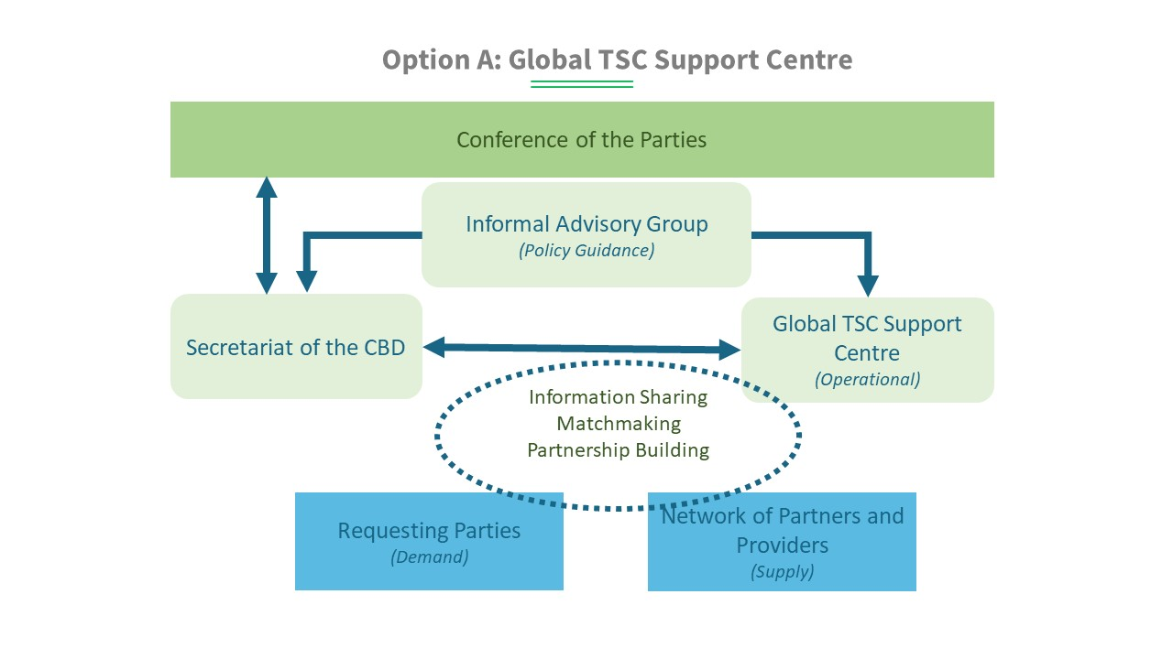

1. The global support centre would require dedicated resources for its operations. If this option is selected, the Conference of the Parties may wish to invite the financial mechanism of the Convention and other donors to provide the global centre with funding to enable it to provide Parties with timely support so that they can access relevant technologies, expertise and other technical support required in order to implement the post-2020 global biodiversity framework effectively.

*Option B: Regional and/or subregional* *technical and scientific cooperation support centres*

1. Under this option, technical and scientific cooperation and technology transfer would be promoted and facilitated through regional and/or subregional centres designated by the Conference of the Parties. The regional support centres would be hosted in existing partner institutions that possess relevant expertise and institutional capacity to provide technical assistance to countries in the region or subregion upon request and to mobilize resources for technical scientific cooperation projects in their respective regions.[16] Criteria for selecting the host institutions for the centres would be considered and approved by the Conference of the Parties at its fifteenth meeting.
2. The regional support centres would carry out functions similar to those of the global centre as described above but would operate within their respective regions or subregions. Where necessary, they would coordinate with other centres to mobilize all the expertise required to fully support the implementation of the post-2020 global biodiversity framework and address priorities identified in their regions or subregions.
3. The centres would work under the strategic guidance of the Conference of the Parties and would take into consideration the relevant guidance and recommendations of the Informal Advisory Group described in paragraph 14 above. The centres would submit progress reports on their activities to the Conference of the Parties through the Secretariat of the Convention. A schematic illustration of the proposed regionally based institutional mechanism to promote and support technical and scientific cooperation, including the relationship between the above components, the Conference of the Parties and other stakeholders, is presented in figure 2 below.

**Figure 2. Schematic illustration of the regional institutional mechanism to support technical and scientific cooperation**

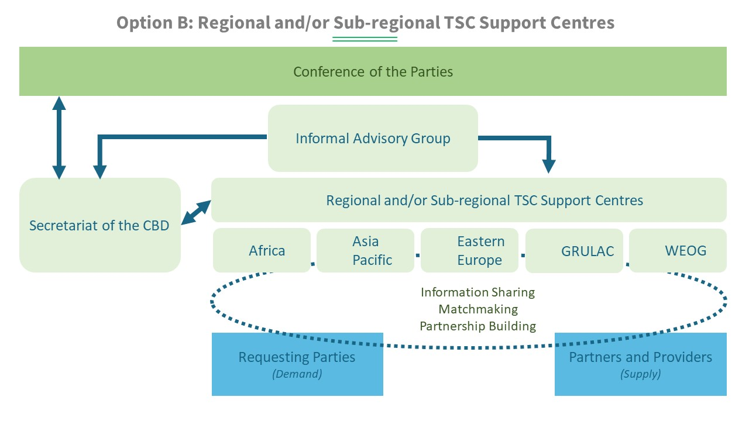

*Option C: Technical and scientific cooperation support through Secretariat-coordinated programmes*

1. Under this option, technical and scientific cooperation and technology transfer would continue to be promoted and facilitated through programmes coordinated by the Secretariat of the Convention in collaboration with partners, including the Bio-Bridge Initiative, the Forest Ecosystem Restoration Initiative, the Global Taxonomy Initiative and the Sustainable Oceans Initiative. Each programme would implement targeted interventions in a specific thematic area. The Secretariat would submit progress reports to the Conference of the Parties, which would take into consideration the guidance of the Informal Advisory Group, as mentioned in paragraph 14 above. Their functions would differ from one programme to another on the basis of the priorities and requirements of donors.
2. The Secretariat would also continue to promote and facilitate technical and scientific cooperation through partnership agreements and collaborative programmes with various partners, including research and academic institutions, international organizations and networks. These might include the Climate Technology Centre and Network (for example on promoting ecosystem-based solutions to climate change), the International Barcode of Life (iBOL), the Global Biodiversity Information Facility (GBIF), the Consortium of International Agricultural Research Centers (CGIAR Centers), and the Biodiversity Observation Network of the Group on Earth Observations (GEO-BON). Others include the Global Partnership for Plant Conservation, the Collaborative Partnership on Sustainable Wildlife Management, the Biodiversity Indicators Partnership, the Global Biological Resource Centre Network (GBRC), the Global Invasive Alien Species Information Partnership, the Global Genome Biodiversity Network (GGBN), the Global Ocean Biodiversity Initiative, the Sustainable Oceans Initiative and the Consortium of Scientific Partners on Biodiversity.[17]
3. To play an effective role in facilitating technical and scientific cooperation in support of the post-2020 global biodiversity framework, the Secretariat would require adequate and predictable funding support. The Secretariat’s core budget would need to provide for dedicated staff positions responsible for technical and scientific cooperation as well as for core activities.

*Role of the Secretariat of the Convention on Biological Diversity*

1. In line with Article 24 of the Convention, the Secretariat of the Convention would:
   1. Prepare relevant documents and reports on technical and scientific cooperation and technology transfer (Articles 16 to 18 of the Convention) for the Conference of Parties and its subsidiary bodies;
   2. Compile relevant information related to technical and scientific cooperation and technology transfer in the field of biological diversity and make it available through the clearing-house mechanism, in line with the knowledge management strategy;
   3. Coordinate, as appropriate, with biodiversity-related conventions, relevant Parties’ agencies, the Consortium of Scientific Partners, the Business and Biodiversity Platform, and other relevant networks and initiatives carrying technical and scientific expertise and/or involved in cooperation;
   4. Co-organize with partners biodiversity science forums, technology and innovation expos and other events on the margins of international meetings;
   5. Perform such other activities as may be necessary to carry out its functions.

*Annex II*

**Draft terms of reference of the informal advisory group on technical and scientific cooperation**

**1. Background**

1. Article 18 of the Convention on Biological Diversity requires Parties to promote international technical and scientific cooperation in the field of conservation and sustainable use of biological diversity, where necessary, through appropriate international and national institutions, including by promoting cooperation in human resources development and institution-building, encouraging and developing methods of cooperation for the development and use of relevant technologies (including indigenous and traditional technologies), promoting cooperation in the training of personnel and exchange of experts, and promoting the establishment of joint research programmes and joint ventures for development of relevant technologies. Article 18 also stresses the importance of the clearing-house mechanism for fostering technical and scientific cooperation.
2. In decisions, VII/29, VIII/12, IX/14, X/15, X/16, XII/2, XIII/23 and XIII/31, the Conference of the Parties adopted a number of measures and provided guidance on various aspects relating to technical and scientific cooperation and technology transfer.
3. In decision 14/24, the Conference of the Parties decided to consider establishing, at its fifteenth meeting, an informal advisory group on technical and scientific cooperation, to be operational at the end of the mandate of the current Informal Advisory Committee to the Clearing-house Mechanism in 2020, to provide the Executive Secretary with advice on practical measures, tools and opportunities to promote technical and scientific cooperation for the effective implementation of the Convention.

**2. Purpose**

1. The Informal Advisory Group on Technical and Scientific Cooperation will provide advice to the Executive Secretary on ways and means to promote and facilitate technical and scientific cooperation, technology transfer, capacity-building, knowledge management, and the clearing-house mechanism in support of the post-2020 global biodiversity framework. In particular, the Informal Advisory Group will provide advice, guidance and recommendations on:
2. Practical measures and approaches to promote technical and scientific cooperation for the effective implementation of the Convention;
3. Measures to enhance collaboration with other relevant international agreements, processes and organizations with respect to technical and scientific cooperation and technology transfer initiatives;
4. Strategic approaches to addressing the needs and priorities of Parties through programmatic implementation of relevant technical and scientific cooperation initiatives established under the Convention;
5. Monitoring the implementation of the strategies on technical and scientific cooperation, capacity-building and knowledge management in support of the post-2020 global biodiversity framework to ensure coherence and consistency;
6. Development and implementation of tools and mechanisms for promoting and facilitating technical and scientific cooperation, capacity-building and knowledge management, including science and traditional knowledge systems;
7. Matters relating to the clearing house-mechanism and, in particular, on how to improve its effectiveness as a mechanism for promoting and facilitating technical and scientific cooperation and exchange of information;
8. Potential opportunities for mobilizing technical and financial resources to promote and sustain technical and scientific cooperation activities;
9. Identification and mapping of existing collaboration activities.
10. The Secretariat of the Convention on Biological Diversity will support the work of the Informal Advisory Group, including the provision of necessary logistical and secretarial support for its work.

**3. Membership**

1. The Informal Advisory Group will be composed of experts nominated by Parties, with due regard to equitable regional representation and gender balance, as well as experts from indigenous peoples and local communities and relevant organizations. The number of experts from organizations will not exceed the number of experts nominated by Parties. Members will be selected on the basis of the following criteria, as evidenced in their curriculum vitae:
   1. At least five years of working experience on technical and scientific issues related to the implementation of the Convention on Biological Diversity and/or other relevant international agreements and processes;
   2. Expertise relevant to technical and scientific cooperation, capacity-building, and knowledge management and the clearing-house mechanism or similar online information-sharing platforms;
   3. Demonstrated experience with regional or international cooperation processes and programmes related to biodiversity and/or the environment.
2. The co-chairs of the Consortium of Scientific Partners on Biodiversity will be invited as ex officio members.
3. Members of the Informal Advisory Group will be selected through a formal nomination process based on the above criteria. The Executive Secretary, in consultation with the co-chairs of the Informal Advisory Group, may invite additional experts knowledgeable in specific issues or thematic areas to be discussed at relevant meetings of the Informal Advisory Group, ensuring a balance of experts on matters related to the Convention. The members will serve in their personal capacity and not as representatives of a government, organization or other entity.
4. Members of the Informal Advisory Group will serve for a term of two years, with a possibility of renewal for one additional two-year term.

**4. Modus operandi**

1. The Advisory Group will meet face-to-face at least once per year, subject to the availability of resources, wherever possible in the margins of other meetings. The frequency of meetings may be adjusted by the members as the need arises. The Group will work intersessionally, as appropriate, and remotely via electronic means.
2. The Advisory Group may, as appropriate, establish subcommittees to support it in addressing specific issues or thematic areas and co-opt relevant experts to assist.
3. The Advisory Group members shall not receive any honorarium, fee or other remuneration from the United Nations. However, costs for the participation of Group members nominated by developing country Parties and Parties with economies in transition will be covered, in line with the rules and regulations of the United Nations.
4. The Informal Advisory Group will elect two co-chairs to serve for a two-year period.
5. The working language of the Group will be English.

__________

1. See the scoping document ([CBD/COP/13/INF/22](https://www.cbd.int/doc/meetings/cop/cop-13/information/cop-13-inf-22-en.pdf)) and the overview provided in section II of the present document.
2. See [UNEP/CBD/WGRI/5/3/Add.1](https://www.cbd.int/doc/meetings/wgri/wgri-05/official/wgri-05-03-add1-en.pdf).
3. See [UNEP/CBD/COP/8/19/Add.2](https://www.cbd.int/doc/meetings/cop/cop-08/official/cop-08-19-add2-en.pdf).
4. See UNEP/CBD/WGRI/3/10.
5. This is pursuant to Article 18, paragraph 2, of the Convention.
6. This is pursuant to Article 18, paragraph 4, of the Convention.
7. This is pursuant to Article 12 of the Convention.
8. This is pursuant to Article 17, paragraph 2, of the Convention.
9. These guiding principles are consistent with the normative and operational principles outlined in the framework of operational guidelines on United Nations support to South-South and triangular cooperation ([SSC/19/3](https://documents-dds-ny.un.org/doc/UNDOC/GEN/N16/081/68/pdf/N1608168.pdf?OpenElement)).
10. Article 12, paragraphs (b) and (c), of the Convention requires Parties to promote and encourage research which contributes to the conservation and sustainable use of biological diversity, particularly in developing countries, inter alia, in accordance with decisions of the Conference of the Parties taken in consequence of recommendations of the Subsidiary Body on Scientific, Technical and Technological Advice, and, in keeping with the provisions of Articles 16, 18 and 20, promote and cooperate in the use of scientific advances in biological diversity research in developing methods for conservation and sustainable use of biological resources.
11. For the purposes of the present document, “innovation” is described as a process that encompasses design, experimentation, application and scaling up of new ideas and solutions, resulting in transformative and more impactful change.
12. Including but not limited to specialized networks, academic and scientific institutions, the private sector, governmental and non-governmental organizations, indigenous peoples and local communities, bilateral and multilateral institutions, and funding institutions.
13. Ibid.
14. Pursuant to decision 14/24 B of the Conference of the Parties.
15. See details at [UNEP/CBD/SBSTTA/19/INF/13](https://www.cbd.int/doc/meetings/sbstta/sbstta-19/information/sbstta-19-inf-13-en.pdf) and <https://www.ctc-n.org/>
16. The regional and/or subregional centres could operate in a manner similar to such entities as the Stockholm Convention regional and subregional centres, which provide technical assistance and promote the transfer of technology to developing country Parties and Parties with economies in transition relating to the implementation of their obligations under the Stockholm Convention (see <http://chm.pops.int/Partners/RegionalCentres/Overview/tabid/425/Default.aspx>)
17. An overview of other relevant initiatives is provided in [UNEP/CBD/WGRI/5/3/Add.1](https://www.cbd.int/doc/meetings/wgri/wgri-05/official/wgri-05-03-add1-en.pdf) and [UNEP/CBD/WGRI/5/INF/2](https://www.cbd.int/doc/meetings/wgri/wgri-05/information/wgri-05-inf-02-en.pdf).