For information media • not an official record

PRESS RELEASE

Review of human health and the Rio Conventions launched at Rio +20

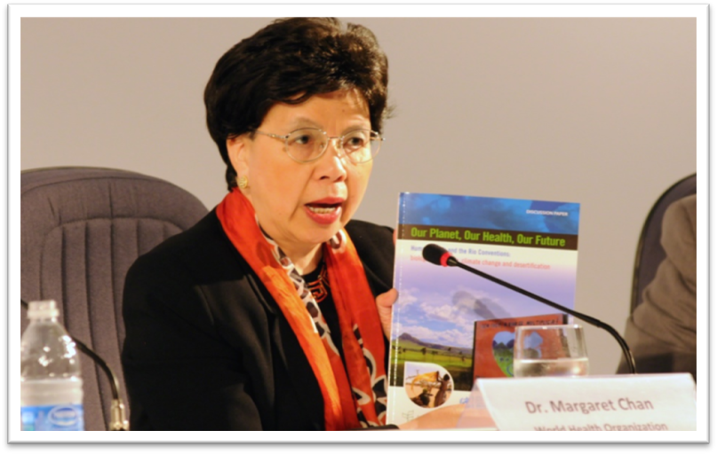
(Dr Margaret Chan, Director-General of the World Health Organization © www.iisd.ca, 2012)

Rio de Janeiro, Brazil, 22 June 2012 – Dr Margaret Chan, Director-General of the World Health Organization (WHO), launched the report, Our Planet, Our Health, Our Future. Human Health and the Rio Conventions: Biological Diversity, Climate Change and Desertification, on 21 June at the Rio+20 conference. The report reviews the scientific evidence for the linkages between health and biodiversity, climate change and desertification, the representation of health in the corresponding Rio Conventions, and the opportunities for more integrated and effective policy. The WHO report was drafted together with the secretariats of the Convention on Biological Diversity (CBD), the United Nations Convention to Combat Desertification (UNCCD) and the United Nations Framework Convention on Climate Change (UNFCCC).

The official launch of the report was included among the celebrations marking the 20-year anniversary of the Rio Conventions, which saw the heads of each of the secretariats reaffirming their commitment to work collaboratively to generate synergies among the conventions in support of sustainable development. A downloadable version of the report is available on the WHO website at: www.who.int/globalchange/publications/reports/healthintherioconventions/en/index.html .

As Braulio Ferreira de Souza Dias, Executive Secretary of the CBD, noted in a recent statement to the 65th meeting of the World Health Assembly: “Over the remaining years of this decade, governments around the world will work to realize targets that have as their goal, building a more sustainable relationship between human communities and the biodiversity that support them. As they engage in this endeavor, it is important to realize what is at stake is the health of the planet and the health of all people”.

Notes to editors

The Convention on Biological Diversity (CBD)
Opened for signature at the Earth Summit in Rio de Janeiro in 1992, and entering into force in December 1993, the Convention on Biological Diversity is an international treaty for the conservation of biodiversity, the sustainable use of the components of biodiversity and the equitable sharing of the benefits derived from the use of genetic resources. With 193 Parties, the Convention has near universal participation among countries. The Convention seeks to address all threats to biodiversity and ecosystem services through scientific assessments, the development of tools, incentives and processes, the transfer of technologies and good practices and the full and active involvement of relevant stakeholders including indigenous and local communities, youth, NGOs, women and the business community. The tenth meeting of the Conference of the Parties to the CBD, held 2010, adopted a revised and updated Strategic Plan for Biodiversity for 2011-2020, comprising five strategic goals and 20 Aichi Biodiversity Targets. The Plan is the overarching framework on biodiversity, not only for the biodiversity-related conventions, but for the entire United Nations system.The Cartagena Protocol on Biosafety is a subsidiary agreement to the Convention. It seeks to protect biological diversity from the potential risks posed by living modified organisms resulting from modern biotechnology. To date, 162 countries plus the European Union have ratified the Cartagena Protocol. The Secretariat of the Convention and its Cartagena Protocol is located in Montreal. For more information visit: www.cbd.int.
For additional information, please contact: David Ainsworth on +1 514 287 7025 or at david.ainsworth@cbd.int; or Johan Hedlund on +1 514 287 6670 or at johan.hedlund@cbd.int.

------------

