Report on the
Preliminary Meeting for the Joint SCBD / SPREP Regional Capacity-Building Workshop on Implementing NBSAPs and Mainstreaming
Biodiversity in the Pacific
With support from the Commonwealth Secretariat

19 October, 2007

Alotau
Papua New Guinea
1. Introduction / Overview / Background

One of the recommendations emerging from the COP-8 (Decision XIII/8 [6]) promoted a series of regional and/or sub-regional workshops on capacity building for NBSAPs. These will be held with the aim to discuss national experiences in implementing NBSAPs, the integration of biodiversity concerns into relevant sectors, obstacles, and ways and means for overcoming these obstacles. It was recommended that these workshops be held (subject to the availability of funding) prior to COP-9, to provide an opportunity to directly support Parties in their implementation and mainstreaming efforts. The recommendation to hold this series of sub-regional workshops was reinforced by recommendation 2 / 1 of the Working Group on Review of Implementation, at its second meeting which was held from 9 – 13 July 2007.

UNEP/CBD/WG-RI/2/INF/2 provides the full background and concept note for a planned series of regional and sub-regional workshops on capacity building for NBSAPs. These will serve as opportunities for Parties to discuss national experiences in developing, implementing and updating NBSAPs, effective approaches to integrating biodiversity concerns across development sectors, main challenges faced, and ways and means for overcoming these challenges. Furthermore, the workshops will provide critical inputs to the in-depth review of the Strategic Plan in which Goal 3 highlights the important role NBSAPs have in mainstreaming the objectives of the Convention and thereby implementing the Convention at national levels

The workshops will be structured as a three to five-day events. Retreat venues are envisioned in order to best facilitate focused and participatory learning activities. Sessions will fall under two principle topic areas:
1) developing, implementing, and updating NBSAPs, and
2) mainstreaming.

The emphasis will be on exchange and active learning. Workshop formats will feature a mix of presentations with question and answer sessions, discussions in small working groups, and structured skill-building modules.

While the workshops will target capacity building for NBSAP planning and updating, implementation, and mainstreaming, each of the workshops will have a specific theme in order to be able to target discussions and activities by focusing on one sector and/or issue that is high on the political agenda for the particular sub-region.

The workshops will draw upon on the practical experience of participants. Specific Parties will be invited to give presentations, based on particular successes they have achieved, or the fact that their country faces obstacles common to many others. Representatives of international organizations, NGOs or other groups that have direct experience in implementation and integration of biodiversity issues will also be invited to share best practices. All Parties will have ample opportunity to comment on presentations and share their own experience. To support the workshops the SCBD, UNEP & UNUIAS have jointly prepared a series of seven (7) training modules that can be flexibly incorporated into the workshop programmes as apropriate. These cover the following areas and can be adjusted and tailored to more specifically address the needs and issues in any one region:

MODULE 1A: Guide to the Convention to the Convention on Biological Diversity
MODULE 2A: Role of CBD National Focal Points
MODULE 3A: An Introduction to National Reporting
MODULE 1B: An Introduction to National Biodiversity Strategies and Action Plans
MODULE 2B: The Biodiversity Planning Process: How to prepare and update an NBSAP
MODULE 3B: Mainstreaming Biodiversity into Sectoral and Cross-Sectoral Strategies, Plans and Programmes
MODULE 4B: Setting Biodiversity Targets, making use of the CBD’s framework for the 2010 Biodiversity Target
MODULE 5B: Ensuring stakeholder engagement in the development, implementation and updating of NBSAPs
MODULE 6B: Getting political support for the NBSAP and financing its implementation
MODULE 7B: Communication Strategy for Issues in NBSAPs

In the Pacific region it has been agreed that this workshop will be conducted jointly by SCBD & SPREP in 2008. In preparation for this workshop a one-day initial meeting was held as a side event at the 8th Pacific Islands Conference on Nature Conservation and Protected Areas in Alotau, PNG on the 19th October 2007.

2. Results of the preliminary meeting

There were six key aims to the meeting:

1- To share experiences in the development and implementation of NBSAPs in the region, and to:
(i) find commonalities in challenges of NBSAP implementation,
(ii) identify areas where support is required,
(iii) identify the challenges and successes of mainstreaming biodiversity
(iv) learn the extent of NBSAP integration into relevant national plans and strategies in the region;
2- To identify Party-specific needs related to completing or updating NBSAPs, obstacles to implementation of NBSAPs and biodiversity mainstreaming;

3- Identify a thematic focus for the 2008 workshop based on priorities from the region;

4- Identify the collective objectives of the 2008 workshop;

5- Identify relevant tools, guidance and good practices on NBSAP development, updating and implementation that can be shared among the participants of the 2008 Workshop
6- Discuss the support role that SPREP and associated organizations can play in providing technical back-stopping for NBSAP development, implementation, review and mainstreaming into the future.

Participants elected Mr. Faumuina Pati Liu as Chair. The facilitators were: Eleanor Carter, SPREP and Oliver Hillel, SCBD. The Rapporteur was Greg Sherley, Terrestrial Conservation Unit, DOC/RDID, NZ. The participants at the meeting were as listed in Table 1.

The discussions at the meeting were lively and informative, and there were considerable exchanges of ideas and experiences in the development and implementation of NBSAPs. These included the identification of the key challenges, obstacles, gaps in existing plans, the importance of political will, the mechanisms to facilitate wide support for NBSAPs and some examples of good practices and successful mainstreaming of NBSAP goals into strategies cemented in legislation. Participants welcomed the report prepared by Ms. Eleanor Carter for SPREP on the status and challenges of NBSAP implementation in the Pacific region, with support from the Commonwealth Secretariat. The report was found to be very useful to all and adopted in its entirety.

In synopsis there were three key outputs of the meeting:

- There was preliminary consensus at the meeting for the focus of the training workshop to be held next year working on capacity building for NBSAP coordinators.
- The meeting revealed that work being undertaken by top level government departments has not necessarily been linked to the goals developed in their NBSAP, despite the fact that much of the work is in fact successfully implementing the NBSAP aims.
- The meeting generated a lot of interest from participants to ‘return to their NBSAPs’, look at them again, consider where they are in the implementation process, what gaps need addressing and re-assess the way in which their NBSAP is being utilized.

Table 1
NAME |  | ORGANISATION | EMAIL
1 | Alissa Takesy | FSM Department of Resources and Development | fsm_pan@mail.fm
2 | Ana Tiraa | SPREP | anat@sprep.org
3 | Celestino Aguon (Tino) | Guam Department of Agriculture, Division of Aquatic & Wildlife Resources | tino_aguon@hotmail.com
4 | David Butler | NZ based consultant | d.butler@xtra.co.nz
5 | Elizabeth Munro | National Environment Service | liz@environment.org
6 | Eric Kwa | UPNG Law School | kwaek@upng.ac.pg
7 | Etika Rupeni | FSPI | etika.rupeni@fspi.org.fj
8 | Faleafaga Toni Tipamaa | MNRE / OLSSI | nationalparks@lesamoa.net
9 | Faumuina VS Pati Liu | MNRE, Samoa | pati.liu@mnre.gov.ws
10 | Gaikovina Kula | Conservation International | gkula@conservation.org
11 | Harry Sakulas | PNG University of Technology ERMC | hsakulai@ermc.unitech.ac
12 | Ian Karika | TCA | kakerori@tca.co.ck
13 | James Sabi | Department of Environment & Conservation, PNG | biodiv@daltron.com.pg
14 | Joel Miles | Palau Office of Environmental Response & Coordination | jmiles@palau-oerc.net
15 | John Genolagani | DEC | john@daltron.com.pg
16 | Jozef Hurutarau | ECD-SI | jhurutarau@gmail.com
17 | Kate Brown | SPREP | kateb@sprep.org
18 | Kesaia Tabunakawai | WWF Fiji Country Programme | ktabunakawai@wwfpacific.org.fj
19 | Leanne Fernandez | Earth to Ocean Consulting | leanneF@earth2ocean.com
20 | Manoa Malani | Ministry of Tourism & Environment (M&E section) | mmalani@govnet.gov.fj
21 | Olive Andrews | IFAW | oandrews@ifaw.org
22 | Pepe Clarke | IUCN Regional Office for Oceania (Fiji) | pepe.clarke@iucn.org
23 | Stuart Chape | SPREP | stuartc@sprep.org
24 | Touasi Tiwok | Vanuatu Environment Unit | rtiwok@gmail.com

From reviewing the draft minutes and drawing out the key themes, recurring issues and priority concerns from the NBSAP coordinators, the key theme for focus at the 2008 workshop appeared to be “mainstreaming biodiversity: from NBSAPs to actual government policy and implementation within the development strategies”.

Therefore proposed slogans for the 2008 workshop are:

Island Opportunities: Using Information for Influence

Island Focus: Biodiversity for development.

Putting ‘Biodiversity’ in the Development agenda

One government, one message: from NBSAPs to development policy.

This theme addresses the root causes of the challenges faced in ‘mainstreaming’ NBSAP goals across key economic sectors (mining, forestry and tourism were highlighted) and inter-departmental agenda’s. To achieve such mainstreaming requires considerable top level political will as well as wider bottom-up community support. In island states where development is often ‘rated through revenue’, the key challenge to garnering this political and societal ‘will’ is in making the linkages between biodiversity and development.

Concurrently however, there are key opportunities in the Pacific region for addressing this challenge. Relatively close-knit government departments (i.e. there are less levels of government to deal with) , traditional tenure regimes and a strong interconnectedness between the natural resource base and people’s livelihoods are all elements that work to facilitate placing biodiversity conservation and sustainable use at the heart of development issues.

Therefore there is a need to identify the mechanisms through which such an association between the sustainable use and conservation of biodiversity and future island development can be articulated by the government departments entrusted with managing the nations natural resources. This can be done through, for example, economic valuations of natural resources (see box). This is just one of many tools that can be used to influence decision makers, and to work towards placing biodiversity and natural resource management central to the development agenda. These tools can be addressed further at the 2008 Workshop.

However, with any efforts to garner support for biodiversity conservation, the ‘direction’ for that support needs to be focused and considered. What are you trying to influence the politicians and wider populace to actually ‘do’?
Economic valuations

Economic valuations can show the tangible connections between natural resources and revenue generation, long-term growth in GDP and debt reduction. Additionally they can show the importance of conservation and the costs of ‘inaction’ in terms of a degraded resource base through over-exploitation, loss of livelihoods, impacts on the health of the populace etc. In other words articulating the immediate costs (in financial terms) of conservation to maintain vital ecosystem services against the future costs of rehabilitating or attempting to recover and rebuild those services.

The NBSAPs have been developed to show the key goals and actions the nation (through extensive consultation) feels is necessary to safeguard its biodiversity. These plans are vital tools to direct management process and identify the key priority conservation issues to address in each nation.

However, many ‘gaps’ exist in current NBSAPs with regards to the prioritization of actions, the timescales in which they need to be carried out, and the key departments and associated players who need to be involved in undertaking the work.

Decision makers need to know what they are promoting, what are they agreeing to, and what ‘targets’ they are trying to reach. The NBSAP can provide all of this information if these ‘gaps’ are addressed.

Therefore in order to work towards influencing political and societal will, and consequently mainstreaming biodiversity concerns, there is a need to ‘close the gaps’ in the NBSAPs and identify the priority actions that are going to be addressed, as well as the mechanisms that are going to be used to monitor and evaluate the effectiveness of any work. It is also important to identify which actions are already being addressed, how they are being addressed and what is their status. Therefore this could be a concurrent focus of the 2008 Workshop.

Additionally recurring issues that arose at the meeting and need to be considered in developing the NBSAP training were:
- Pacific islands maintain strong links to indigenous culture, and traditional land-tenure instruments. Land traditional knowledge is highly valued.
- Due to their relative isolation, and the need to network resources, islands in the Pacific have high levels of coordination at regional level. This is a strength that should be capitalized upon.

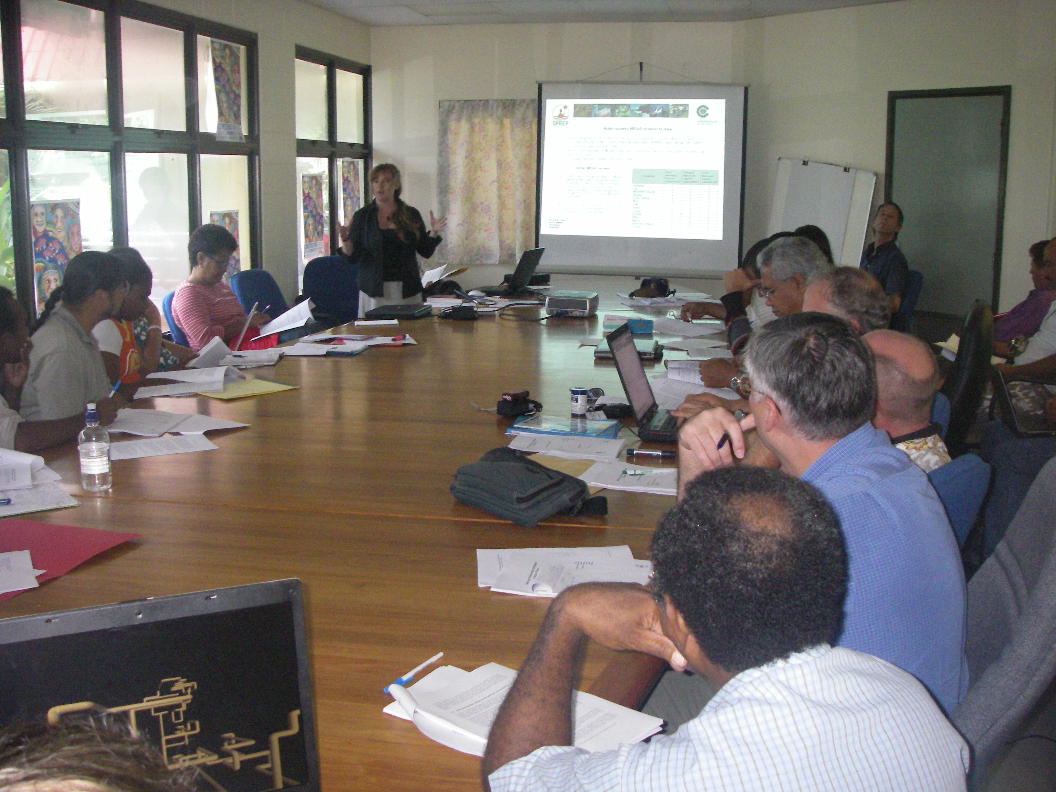
NBSAP meeting - PNG - 19 October 2007

Suggested / draft workshop schematic:

Half-day (prior to workshop): Additional training day provided for LDCs and nations still in the development of their NBSAPs (and other interested parties) in:
- the 6 ‘W’s of strategy development (What, Where, When, Who, Why & How);
- Monitoring & Evaluation protocols;
- The SCBD – its role and its initiatives (PoWs)

Day One: Tools to influence decision makers in support of mainstreaming biodiversity concerns, and NBSAP implementation.
- Experiences from the region
- Lessons learned and celebration of successes in implementation (what mechanisms have been effective to date in informing and influencing decision makers in Pacific nations? How was the issue of biodiversity picked up by politicians? What made it work, and which skills were necessary?)
- What are the key particularities relevant to the Pacific that need to be considered in identifying the right tools to place biodiversity conservation into the development agenda, e.g:
- development ‘rated by revenue’;
- addressing the ‘enduring challenges’ i.e enormous pressure for natural resource extraction in some countries;
- large marine EEZs;
- Issues of governance and challenges of ensuring compliance of environmental regulations with limited personnel available;
- Considerable opportunity for bottom-up conservation and the role of the government in providing a regulatory and economic framework in which to encourage community level conservation;
- Etc etc
- What tools are available (e.g. economic valuations, motivating public support for conservation, maintaining high level awareness of the links between livelihoods and natural resources etc), and where can countries go to get support to develop and use these tools (role of SCBD and regional support organizations, available specialists, relevant institutions etc).

Day two: Addressing the ‘gaps’ in the NBSAPs. What are your priority focus areas, what do you want your leaders to do? How can you use your NBSAP more effectively?

Day three: Identifying the ‘next steps’. What are the individual nation states going to take away from this workshop? What support do you need? How are you going to share this information with the rest of your department back home? What happens next?

This CBD sub-region includes the following countries: Samoa, Cook Islands, Fiji, Niue, Marshall Islands, Federated States of Micronesia, Vanuatu, Palau, Tonga, Kiribati, Papua New Guinea, Solomon Islands, Tuvalu and Nauru.

