Work on the online forum on invasive alien species
You are registered to provide information to develop technical guidance on invasive alien species management which include practical tools and methods. Such information will be considered by the Ad Hoc Technical Expert Group meeting to develop a CBD guidance on management of invasive alien species.
The discussion will be moderated in a schedule as below. The moderator will be introduced at the beginning of each session.
Session 1: Methods for cost-benefit analysis | 1 – 31 May 2019
Session 2: Methods, tools, and measures for identification and minimization of risk of e-commerce | 1 – 30 June 2019
Session 3: Methods, tools and strategy for invasive alien species management under climate change and others | 1 – 31 July 2019
Session 4: Risk analysis on the potential consequences on social, economic and cultural values | 1– 31 August 2019
Session 5: Wrap up session for synthesis of report | 1 – 15 September 2019

Work not covered by the online forum
The Ad Hoc Technical Expert Group will consider practical tools and methods for Parties to manage invasive alien species. Assessment of invasive alien species that is on-going under IPBES is not included in the work of this online discussion forum. We note that the work under the IPBES will become relevant in the management of IAS when its assessment is completed.
How to post and comment your information
- Access with your web browser at https://www.cbd.int/invasive/forum2/
- Sign in (click the “Sing in” see the arrow in the image below)
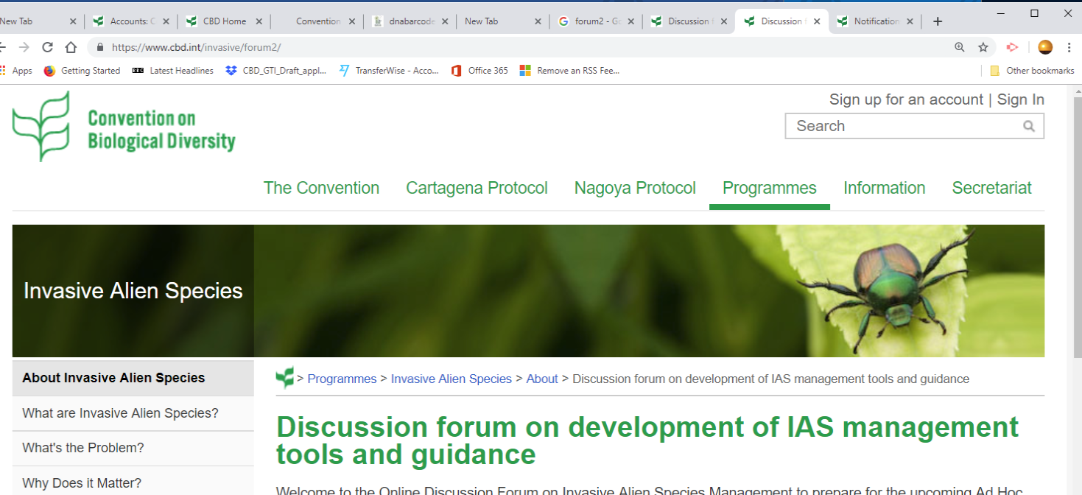

- Sign in with your email address and password. If you have not set a password, click forgot password and set your own password.
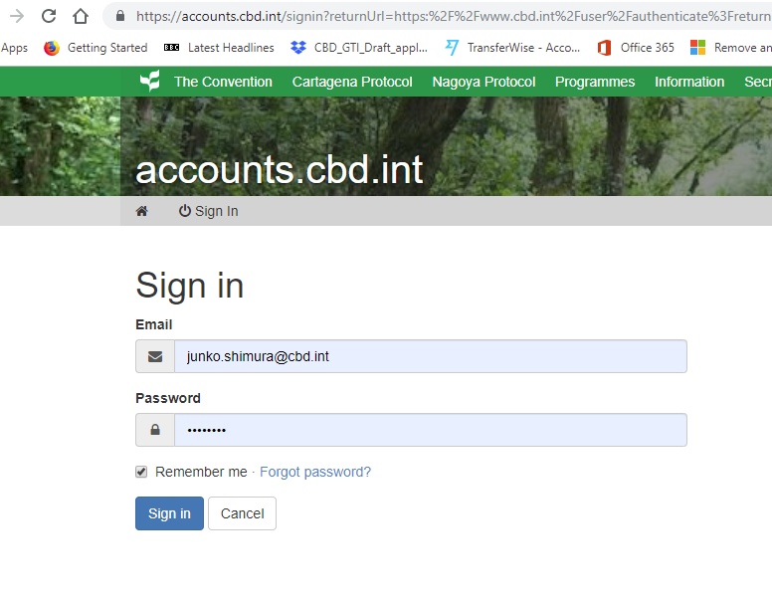
- Click the blue string which will take you to a message posted
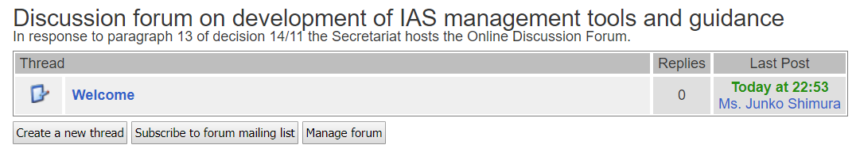
- You can then reply to the message with comments.
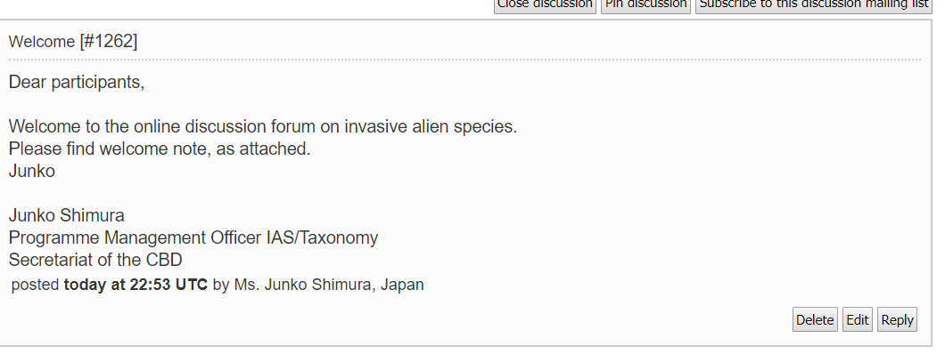
you will type in your comments in a window which pops up. You can also post files with attachment on the same window.

What moderator does:
At the beginning of each session a moderator will provide a brief introduction and initiate discussion by providing known examples of tools, methods, internationally recognized standards or guidance etc.

The moderator may also provide information on scientific projects/processes on-going to elaborate new methods and tools.

To focus on the discussion in a good stream, please agree with the moderator to create a new thread and participants will reply to the posting within the thread. If a new thread is required any participant can ask the moderator to create a separate thread by replying within the primary thread.

The moderator can close the thread when enough information is accumulated and well discussed among the participants to inform to the Ad Hoc Technical Expert Group on the subject.

In case the subject matter is complex, the moderator may provide clarification or suggestions to keep the discussion flowing.

Moderator(s) and Secretariat are allowed to post/comment/edit or delete (if a posting was inappropriate, see terms of use) on any posting.

Some terminology:
Keep the CBD terminology when you post your comments. Do not create a new terminology, or comment on different terminology developed by other Conventions or organizations. Such discussion can be done in a separate process.
Article 8h of the Convention states: Prevent the introduction of, control or eradicate those alien species which threaten ecosystems, habitats or species. Therefore, ‘invasive alien species’ in this discussion forum means alien species which threaten ecosystems, habitats or species.
Invasive alien species may include pests and pathogens which also threaten ecosystems, habitats or species. In this context, agricultural fields, production forests and marine/aquatic ecosystems are highly relevant to our discussion.
Sanitary and phytosanitary measures that is applied for safeguarding animal and plant health are important tools/methods to be discussed. If you post/comment about the information on international standards/guidelines/recommendations, it will be very kind if you add some explanation about your biodiversity concerns.
Taxonomy is important to specify the organisms of concern. Use scientific name at a possible lowest level of taxonomic rank (if needed, subsp. var. or genotype and other relevant description on the traits)
____

